

Tic tac toe ai model

Using LMS error function



**Name: Sri sai vijaya aditya nittala**

**roll no.: 177163**

**Section: A**

The **Least Mean Squared** weight update rule is derived from the **Least Mean Squared** error function. This function is essentially average of the square of the distance between our prediction and the target value.

The weight update rule is:

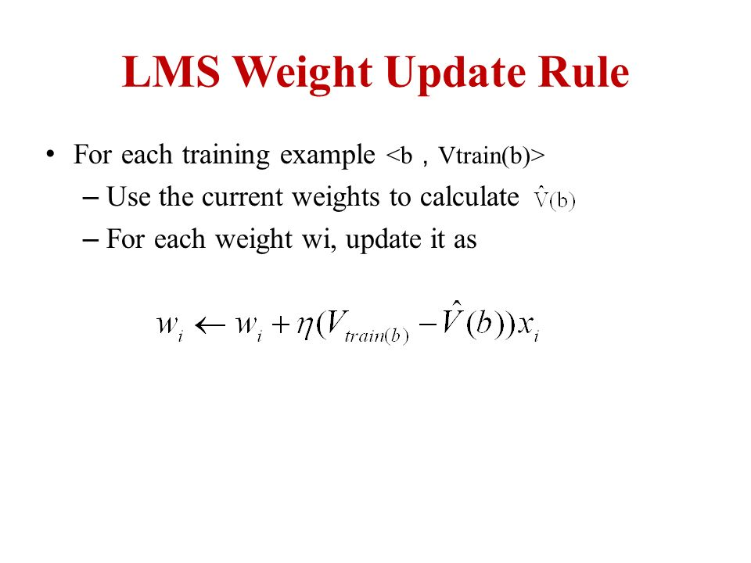

Where:

* *Vtrain(b)* is the target for the training example *b*.
* *V(b)* is the hypothesis obtained from the weighted sum of input features and weights.
* η is the learning rate.

**Input feature extraction from a given 4x4 Tic Tac Toe board:**

There are **8*size + 1** number of features:

* 1 is for the bias
* For n {from 1 to size}:
  + - * + Number of rows with n Xs
        + Number of rows with n Os
        + Number of columns with n Xs
        + Number of columns with x Os
        + If major diagonal has n Xs
        + If major diagonal has n Os
        + If minor diagonal has n Xs
        + If minor diagonal has n Os